LA SALLE UNIVERSITY

COLLEGE OF COMPUTER STUDIES

Software Design Description
For
CodeTest A Role Playing Game

By:
Espadera, Wilfred
Solas, Justine Joy
Vapor, Renz Ryan

Signature

Justine Joy Solas Renz Ryan Vapor
Budget Officer, Researcher and Writer, System Analyst and
Game Programmer Game Programmer

Wilfred Espadera
Team Leader, System Analyst,
Game Programmer

Change History
Date | Reason for changes | Version
3/21/2018 | HIPO  Incorrect template | 1.0.1

Preface
The Following Software Design Description (SDD) describes the proposed plan to be taken by the students of the College of Computer Studies of La Salle University-Ozamiz. As such, it deals only with the delivery of the software component of the project and has dependencies on the Hardware portion of the products since it will be distributed to desktops of computer labs of the said school except for those computer that are running MacOS.

Table of Contents

Signature 2
Change History 3
Preface 4
Table of Contents 5
List of Figures 6
List of Tables 7
1. Introduction 8
1.1. Purpose 8
1.2. Scope 8
1.3. Definitions and Acronyms 8
2. References 9
3. Decomposition Description 10
3.1. Module Decomposition 10
3.1.1. Module 1 Description 10
3.1.2. Module 2 Description 10
3.2. Concurrent Process Decomposition 10
3.2.1. Process 1 Description 10
3.2.2. Process 2 Description 10
3.3. Data Decomposition 10
3.3.1. Data Entity 1 Description 10
3.3.2. Data Entity 2 Description 10
4. Dependency Description 11
4.1. Inter-module Dependencies 11
4.2. Inter-process Dependencies 11
4.3. Data Dependencies 11
5. Interface Description 12
5.1. Module Interface 12
5.1.1. Module 1 Description 12
5.1.2. Module 2 Description 12
5.2. Process Interface 12
5.2.1. Process 1 Description 12
5.2.2. Process 2 Description 12
6. Detailed Design 13
6.1. Module Detailed Design 13
6.1.1. Module 1 Detail 13
6.1.2. Module 2 Detail 13
6.2. Data Detailed Design 13
6.2.1. Data Entity 1 Detail 13
6.2.2. Date Entity 2 Detail 13
7. Appendices 14
8. Index 15
9. Annexes 16
9.1. Data flow diagram (optional) 16
9.2. Class diagram 16
9.3. Use case realization (Sequence diagram / Communication diagram) 16
9.4. User interface design 16
9.5. Entity-relationship diagram 16

List of Figures
5.1.1 Main Menu 21
5.1.2 Select C Topic and Character 22
5.1.3 Pause Game 23
5.2.1.1 Navigating Level Areas 24
5.2.1.2 Encountering an NPC 24
5.2.1.3 Instructing Player 25
5.2.1.4 Player Victory 25
5.2.2.1 Volume Graphics and Screen Resolution 26
9.1.1 Class Diagram 35
9.2.1 Continue Game 36
9.2.2 Exit Game 36
9.2.3 Options 37
9.2.4 Pause Game 37
9.2.5 Play Game 38
9.2.6 Quit Game 38
9.3.1 Main Menu 39
9.3.2 Select C Topic and Character 39
9.3.3 Pause Game 40
9.3.4 Options 40
9.3.5 Navigating Level Areas 41
9.3.6 Encountering an NPC 41
9.3.7 Instructing Player 42
9.3.8 Player Victory 42
9.4.1 Entity Relationship Diagram 43

List of Tables
Signature 2
Change History 3
Preface 4
Table of Contents 5
List of Figures 8
List of Tables 10
1. Introduction 11
1.1. Purpose 11
1.2. Scope 11
1.3. Definitions and Acronyms 12
2. References 14
3. Decomposition Description 15
3.1. Module Decomposition 15
3.2. Concurrent Process Decomposition 15
3.3. Data Decomposition 19
4. Dependency Description 20
4.1. Inter-module Dependencies 20
4.2. Inter-process Dependencies 20
4.3. Data Dependencies 21
5. Interface Description 22
5.1. Module Interface 22
5.2. Process Interface 24
6. Detailed Design 28
6.1. Module Detailed Design 28
6.2. Data Detailed Design 33
7. Appendices 34
8. Index 35
9. Annexes 36
9.1. Class diagram 36
9.2. Use case realization (Sequence diagram / Communication diagram) 37
9.3. User interface design 40
9.4. Entity-relationship diagram 4
4

Introduction
Software Design Description describes the whole description of the system together with its modules, data decomposition and class diagram in order to meet and accomplish all the requirements needed to complete and finish the said system

Purpose
The purpose of this document is to describe the design phase of the project. It defines the architectural and structural design of the system. It will be described through diagrams, user interfaces and other modeling structures.
This document describes the detailed structures of the CodeTest - A Role Playing Game and the implementation details required to satisfy the requirements as specified in the previous Software Requirements Specification. It also defines the implementation details of the desired behavior given the requirements within it

Scope
The “CodeTest RPG” is an offline role playing game which allows CCS Students of La Salle University to test their skills and knowledge in the C programming language. The system should be free to be accessed by the students through computers installed with the said system. It is a 2D top down role playing game, in which the game’s objective is to defeat his/her former bestfriend turned villain and its evil organization hell bent on taking over the world through making his/her way to the level areas of the game. Players must take on NPC’s on the said level area and also complete challenges before the player proceeds to the next level area. This system is intended to improve the skills in programming of the said programming language.

Definitions and Acronyms

Term | Definition
Class Diagram | in the Unified Modeling Language (UML) is a type of static structure diagram that describes the structure of a system by showing the system's classes, their attributes, operations (or methods), and the relationships among objects.
Entity Relationship Diagram | is a data modeling technique that graphically illustrates an information system's entities and the relationships between those entities. An ERD is a conceptual and representational model of data used to represent the entity framework infrastructure.
Module | is a part of a program. Programs are composed of one or more independently developed modules that are not combined until the program is linked.
Process Description | is a method used to document, analyze and explain the decision-making logic and formulas used to create output data from process input data. Its objective is to flow down and specify regulatory/engineering requirements and procedures.
SDD | is a written description of a software product, that a software designer writes in order to give a software development team overall guidance to the architecture of the software project
Sequence Diagram | shows object interactions arranged in time sequence. It depicts the objects and classes involved in the scenario and the sequence of messages exchanged between the objects needed to carry out the functionality of the scenario. Sequence diagrams are sometimes called event diagrams or event scenarios.
System Design | is the process of defining the architecture, modules, interfaces, and data for a system to satisfy specified requirements. Systems design could be seen as the application of systems theory to product development
UI | is everything designed into an information device with which a person may interact. This can include display screens, keyboards, a mouse and the appearance of a desktop. It is also the way through which a user interacts with an application or a website
[Table 1.3.1] Definition and Acronyms

References
Combelis, Berenesvicus and Dagiene. (2016). Learning Programming through Games and Contests: Overview, Characterisation and Discussion : Vilnius University. Retrieved from http://www.ioinformatics.org/oi/pdf/v10_2016_39_60.pdf
Lales, Demetri. (2014). New Learning Times: Article Code Combat. Retrieved from https://newlearningtimes.com/cms/article/1547/code-combat
Menard, Michelle. (2011). Game Development with Unity. Retrieved from http://www.worldcat.org/title/game-development-with-unity/oclc/704272271/viewport
Pile, John. (2016). 2D Graphics Programming for Games: CRC Press. Retrieved from https://www.scribd.com/document/319864136/2D-Graphics-Programming-for-Games-pdf
Pressman, R. (2012). Software Engineering: A Practitioner’s Approach. New
York, NY: McGraw-Hill.
Seng and Yatim (2013). Computer Game as Learning and Teaching Tool for Object Oriented Programming in Higher Education Institution: Elsevier Ltd. Retrieved from http://www.sciencedirect.com/science/article/pii/S1877042814014554

Decomposition Description

This section includes a hierarchical structure of entities. Each entity is determined and briefly mentioned in this section. The document will describe the design entities that compose the whole system development environment. The system is composed of two components the server and the interface components. These two components will break into smaller modules according their structure and functionalities.
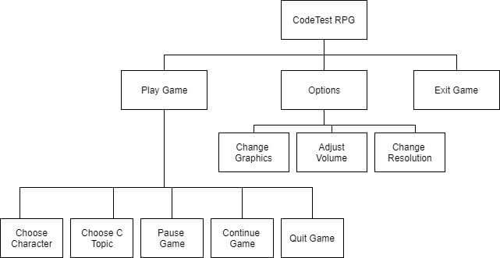

Fig. 1: Decomposition Description

Module Decomposition

3.1.1. Play Description
This module lets the player load a new game, select a C topic and a character. It includes the gameplay with a top-down 2D level areas.
3.1.2. Option Description
This module manages the game settings of the game system. It allows the player to set the game’s graphics, volume or the screen resolution of the game in order to ease the gameplay of the user

3.1.3. Exit Game Description
This module manages the termination of the game if the button is pressed. It closes the game, leads user to his/her desktop.

Concurrent Process Decomposition

3.2.1. Play Description

Name: Play
User action: The user clicks the Play Game button
System Response: System will create a new game
Pre-condition: The user is on the Main Menu
Post-condition: C Topic and Character Selection Screen

3.2.3. Option Description

Name: Option
User action: The user clicks the Option button
System Response: System will display different game options
Pre-condition: The user needs to adjust game settings
Post-condition: Return to Main Menu

3.2.4. Exit Description

Name: Exit
User action: The user clicks the Exit button
System Response: System will terminate the game
Pre-condition: The user wants to close the game
Post-condition: User’s desktop

3.2.5. Select C Topic Description

Name: Select C Topic
User action: The user selects a topic from the dropdown selection
System Response: System waits until the user has selected a character
Pre-condition: The user selects a programming topic
Post-condition: The character selection is enabled

3.2.6. Character Selection Description

Name: Character Selection
User action: The user clicks chosen character
System Response: System will proceed to the game play
Pre-condition: The user selects a character
Post-condition: The user can play the game

3.2.7. Pause Game Description
Name: Pause Game
User action: The user clicks pause button
System Response: System will pause the game and display the continue button, option button and exit to main menu button
Pre-condition: The user is playing the game
Post-condition: The game is paused

3.2.8. Continue Game Description
Name: Continue Game
User action: The user clicks continue button
System Response: System will resume the game
Pre-condition: The game is paused
Post-condition: The system will resume the game

Data Decomposition

3.2.1. Keyboard key Description
This entity will be the bases of the character’s action and it will allow the player to command his/her character in the actions that will be used in the game.

Dependency Description

Inter-module Dependencies
- The C topic selection module and character selection module is dependent on the play game module. The user can play the game if the user selects his/her desired c topic and character for the game. If the user select a c topic but didn’t select a character the user cannot play the game, and if the user have selected a character but failed to select a c topic the user cannot play the game.
- The change graphics, adjust volume and change resolution is dependent on the options module. The user will not be able to adjust game settings if the user will not proceed to the option module have game setting changes.

Inter-process Dependencies
- The continue game process is dependent in the pause game process because if the user wants to pause the game and go back to the current game the user will just click the continue button to resume the game.
- The exit game process is dependent on the play game process because if the user wants to quit or exit the game the user should be on the play game.
- The pause game process, continue game process, quit game process is dependent on the play game process. The user will not be able to pause, continue and quit the game if the user is not on the game play.

Data Dependencies

The keyboard keys will be the data dependencies of the game, the actions of the character will depend on the keyboard keys that the user have pressed while playing the game.

Interface Description

In this section, each user interface is explained along with screenshots of user interfaces

Module Interface

5.1.1 Main Menu Description

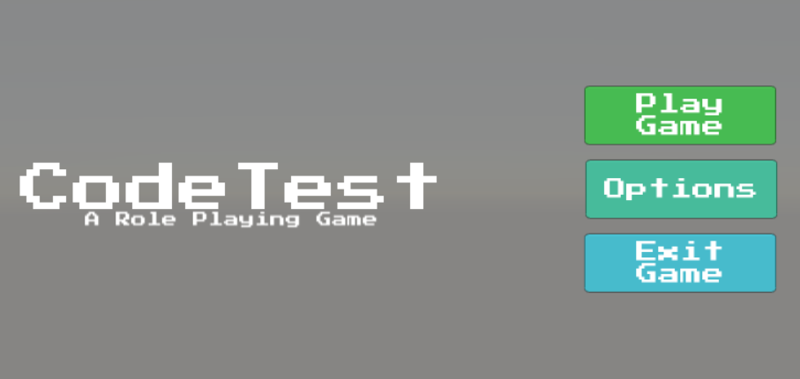
Figure 5.1.1 Game Main Menu Interface
The figure above shows the user interface system of the game which inlcudes Play Game, Options and Exit Game. Play Game has sub menu in which the player must select a C Topic and a character to be used before playing the actual game. Options has also sub menu buttons for the players to reduce the game’s resolution, graphics and volume.

5.1.2 Select C Topic and Character Description

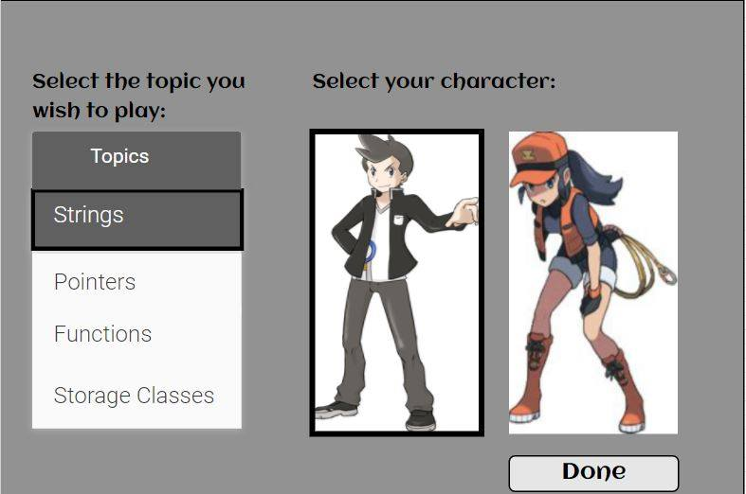
Figure 5.1.2 Select C Topic and Character
After clicking the “Play Game” button located in the Main Menu of the game, the figure above shows a dropdown menu of topics to be choose and a male or female character in which only one can be selected for the player to use the chosen character in game.

Pause Game Description
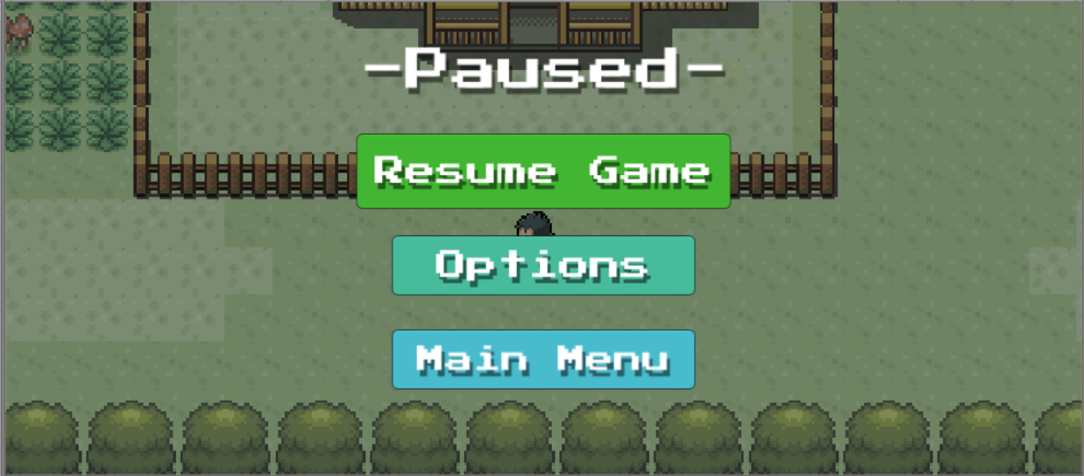
Figure 5.1.3 Pause Game
When the player pauses the game, the figure above shows the buttons that will be displayed when pausing. Quitting the game redirects the user to the main menu of the game

Process Interface

Play Description
The figures below shows the process that will be found once the player starts playing the game. Players can find infrastructures, weird rock formations, roads that leads to the players demise and others from navigating routes or areas of the town. On the side of the road or inside the buildings, player might encounter NPC’s. They might be just open for conversation or aggressive enough to enter the combat phase and is the main objective of making the game. The NPC instructs the player on what should be the output and hands a one-item test case to be answered. Hints will be gained by chance after defeating the NPC.
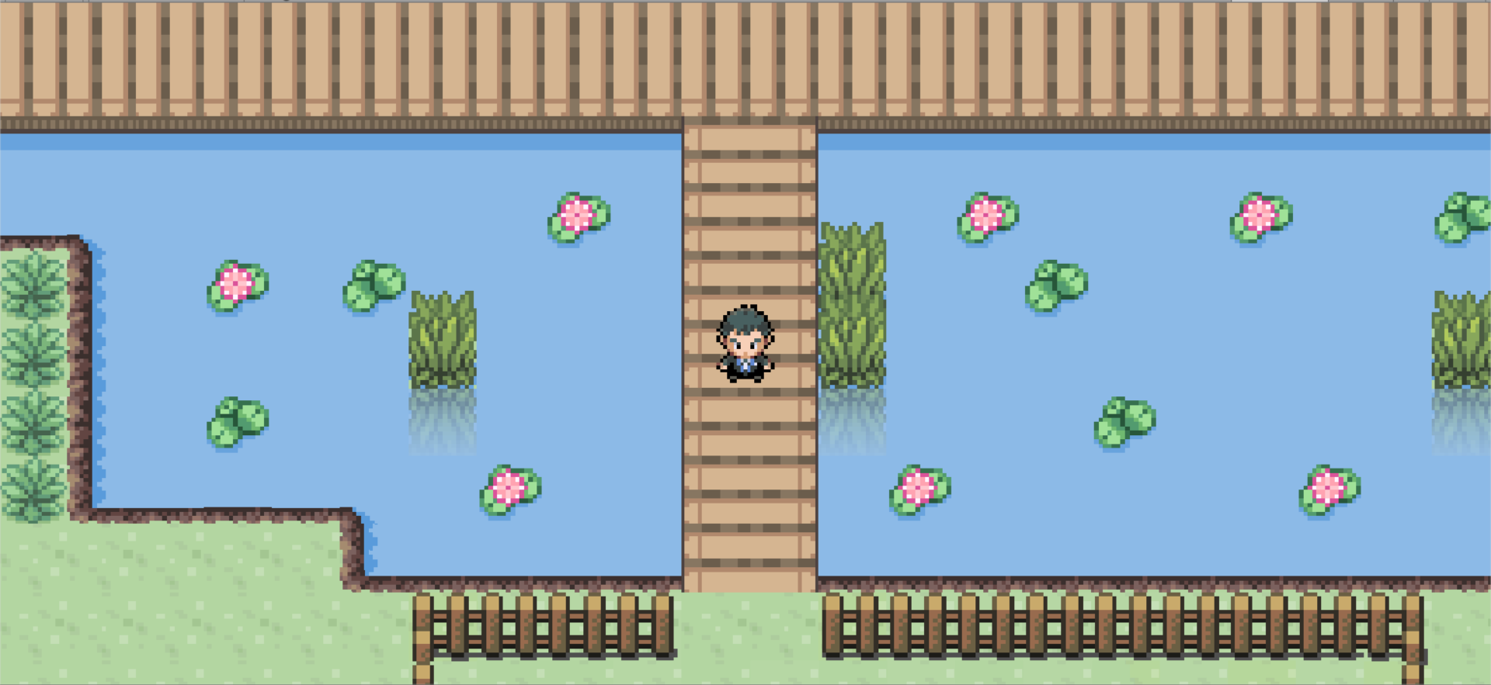
Figure 5.2.1.1 Navigating Level Areas

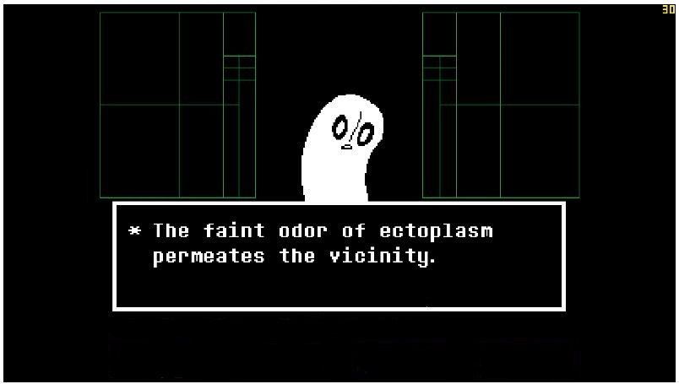
Figure 5.2.1.2 Encountering an NPC

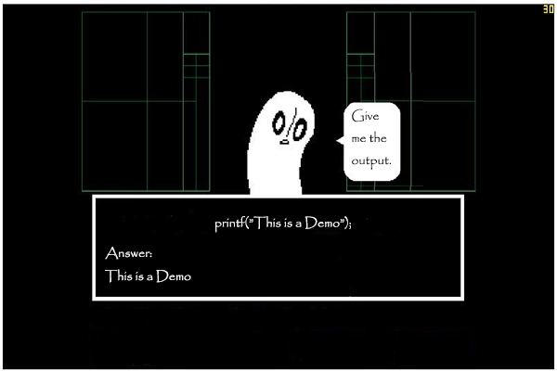
Figure 5.2.1.3 Instructing Player

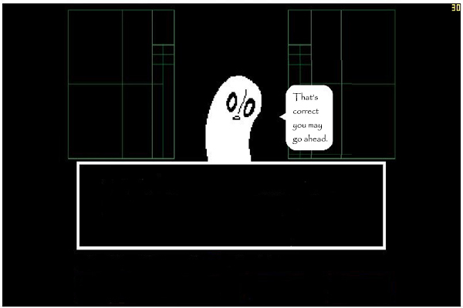
Figure 5.2.1.4 Player Victory

Options Description
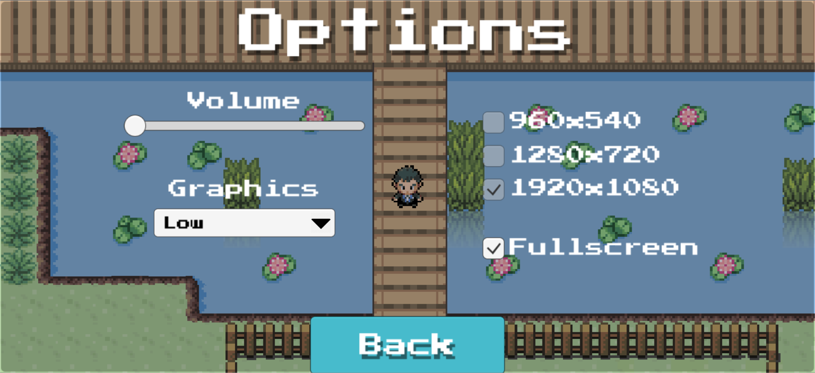
Figure 5.2.2.1 Volume, Graphics and Screen Resolution
The figure above shows that after clicking the Options button will result in displaying the three buttons that will be responsible for running the game smoothly or depending the user’s choice of adjustments and less hassle if the game’s BGM is too noisy.

Detailed Design

Play Game Detail
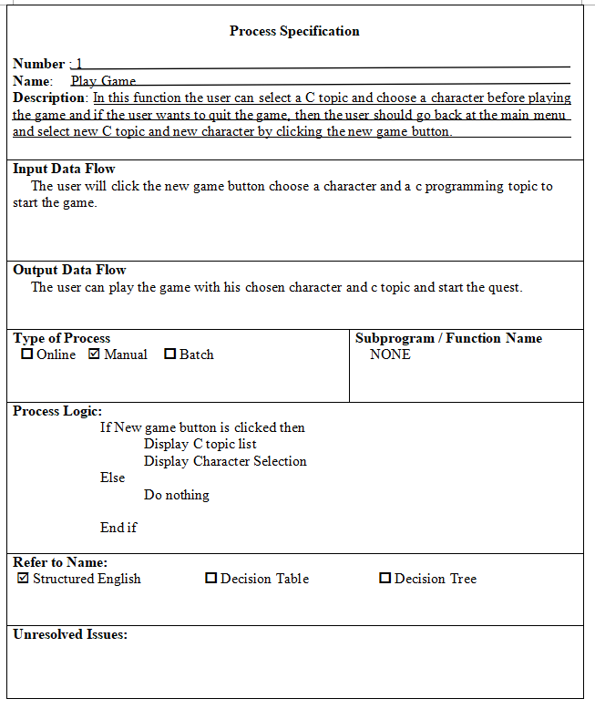

Continue Game Detail
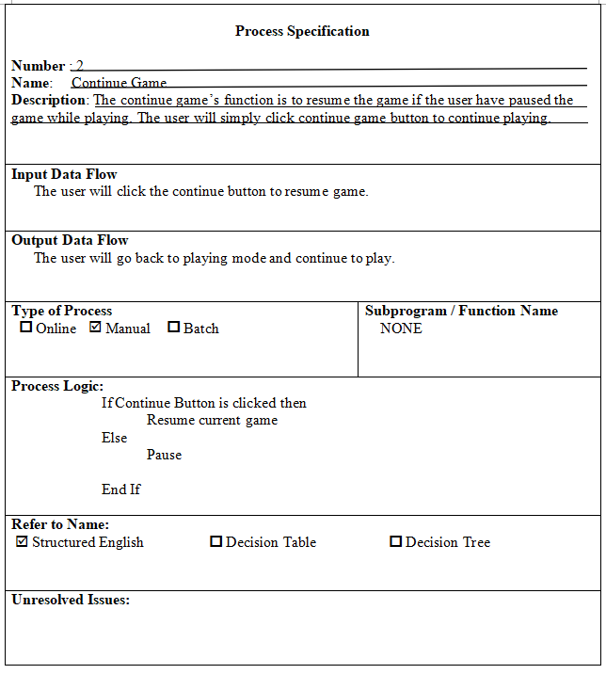

Options Detail
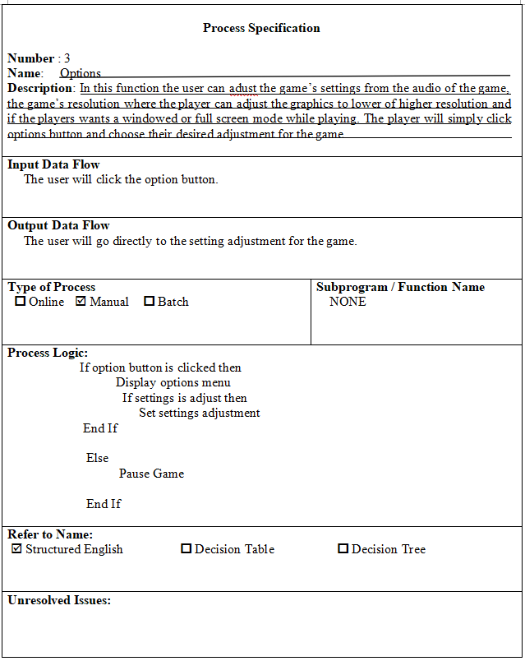

Pause Game Detail
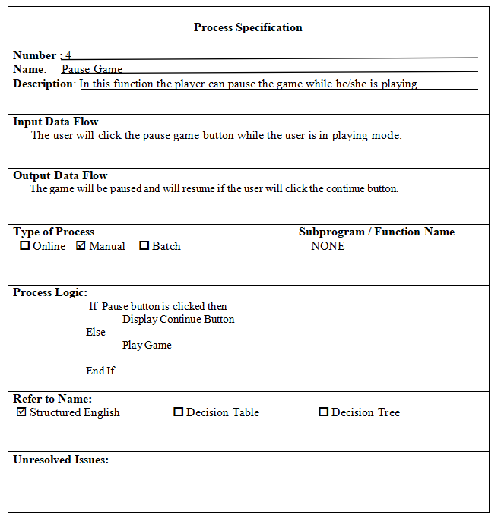

Exit Game Detail
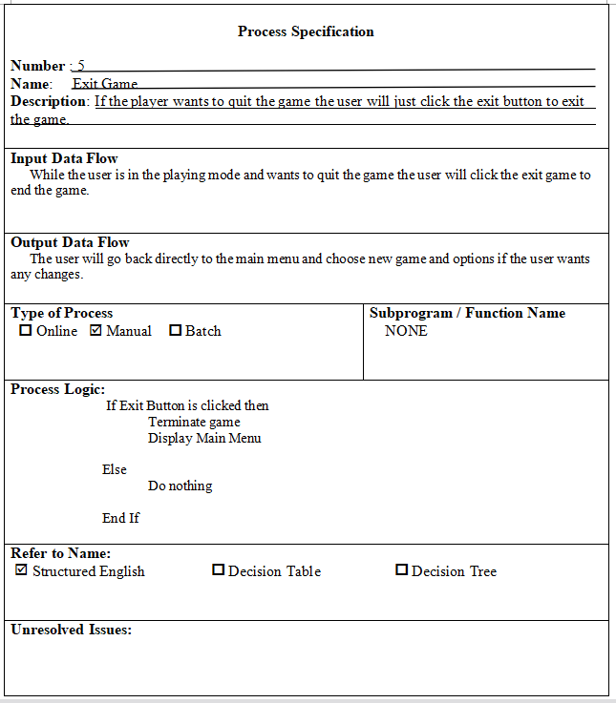

Data Detailed Design

6.2.1Data Name Detail
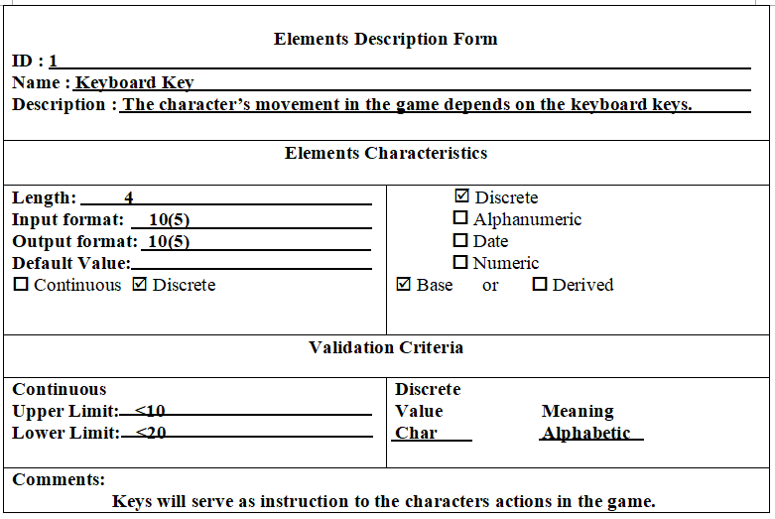

- Appendices
- Index
- Annexes

9.1. Class diagram
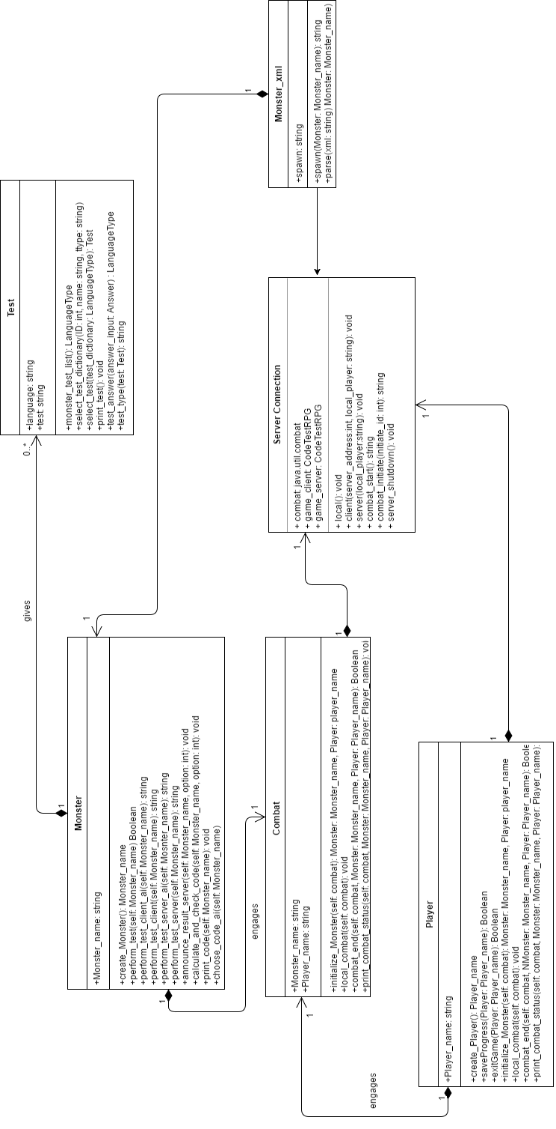

9.2. Sequence diagram / Communication diagram
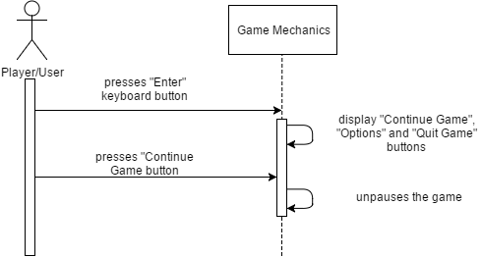
Figure 9.2.1 Continue Game

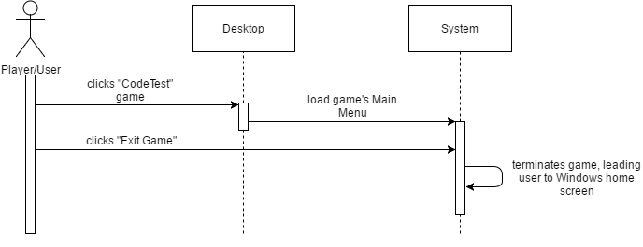
Figure 9.2.2 Exit Game

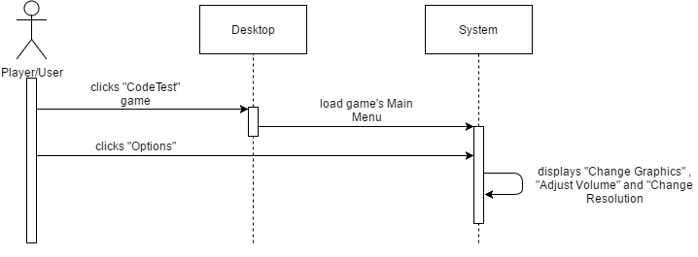
Figure 9.2.3 Options

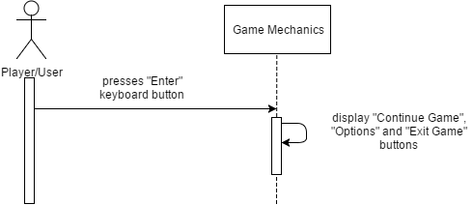
Figure 9.2.4 Pause Game

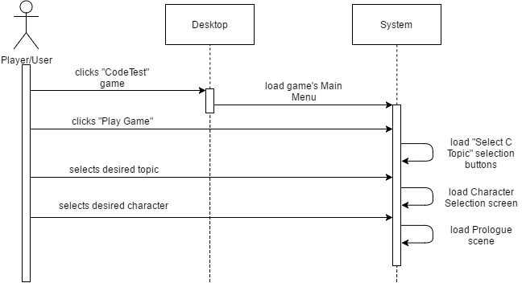
Figure 9.2.5 Play Game

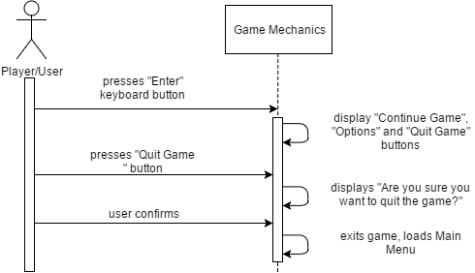
Figure 9.2.6 Quit Game

9.3. User interface design
Figure 9.3.1 Main Menu

Figure 9.3.2 Select C Topic and Character

Figure 9.3.3 Pause Game

Figure 9.3.4 Options

Figure 9.3.5 Navigating Level Areas

Figure 9.3.6 Encountering an NPC

Figure 9.3.7 Instructing Player

Figure 9.3.8 Player Victory

9.4. Entity-relationship diagram

as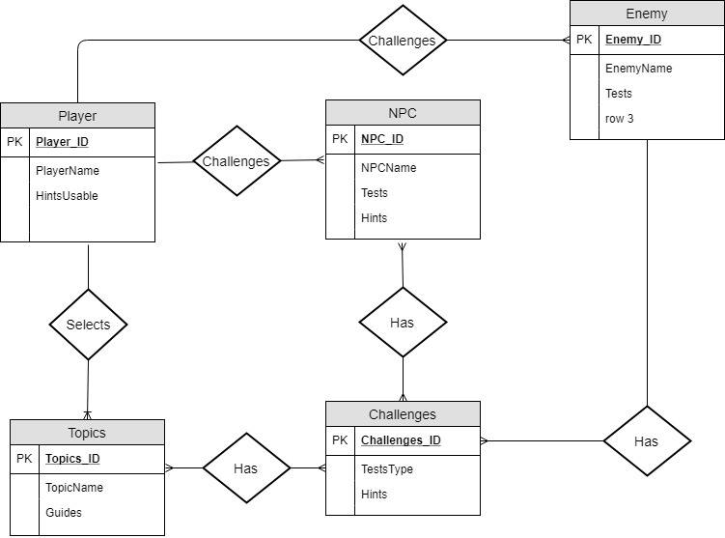

Figure 9.4.1 Entity Relationship Diagram

